Tomcat Server

Starten des Testservers -->

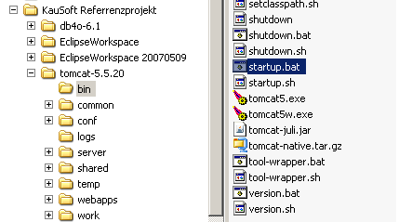
http://localhost:8081/

admin / admin

